RECIPE OF DAL MAKHANI

**1 Tbsp(13.0 gm) Black Urad Dal**

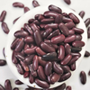

**2 Tsp(10.0 gm) Rajma**

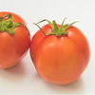

**3 Tbsp(38.0 gm) Tomato (Chopped)**

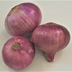

**1.5 Tbsp(12.0 gm) Onion (Chopped)**

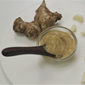

**1 Tsp(5.0 gm) Ginger Garlic Paste**



**1/2 Tsp(0.17 gm) Kasuri Methi**

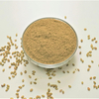

**1/4 Tsp(0.41 gm) Dhania Powder**

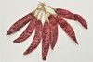

**1/4 Tsp(0.54 gm) Red Chilly (Powder)**

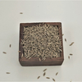

**1/4 Tsp(0.59 gm) Jeera**

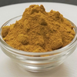

**1/8 Tsp(0.29 gm) Haldi**

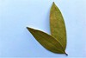

**1 No.(0.3 gm) Bay Leaf**

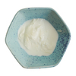

**2 Tsp(8.0 gm) Cream**

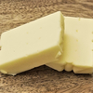

**2 Tbsp(23.0 gm) Butter**

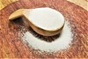

**1/4 Tsp(1.0 gm) Salt**

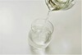

**As Required(70.0 ml) Water**